TITLE OF THE PAPER IN UPPER CASE (Calibri Bold, 14 pt, centered)
Petar Petrović ¹ [ORCID 0000-1111-2222-3333], Marko Marković ¹ [ORCID 0000-1111-2222-3333]
¹ Faculty of Technical Sciences, Department of Industrial Systems and Management, Novi Sad
(Calibri, 11 pt, Italic, centered)

Abstract: This is the guideline for submitting a paper for the 19th International Scientific Conference of Industrial Systems - IS'23,. (Calibri Light, Italic, 10pt). The maximum number of words in an abstract is up to 200 words.
Key words: conference, guideline (Calibri Light, Regular, 10pt)
1. SECTION (INTRODUCTION) (Calibri, uppercase, 12pt)
Text: Calibri Light 10 pt, single spaced, justified. Titles (Calibri, uppercase, 12pt, space before and space after 12pt) and subsections (Calibri, Bold, 10pt, space before 12pt, space after 6pt) within the text should be numbered.
Paper size is A4 (210 x 297 mm). Margins are (mirror margins): TOP = 2,5 cm BOTTOM = 2,5 cm, INSIDE/OUTSIDE = 3 cm.
Language: English only.

2. SECTION (METHODS)
Figures/drawings must be integrated into text and qualities (300 PPI). Number all figures and tables and refer to them in the text as Figure 4 or Table 1. Titles in Calibri 9 pt, Italic should be placed bellow Figures (centered) and above Tables (align left). Text in Tables should be in Calibri Light, 9 pt.

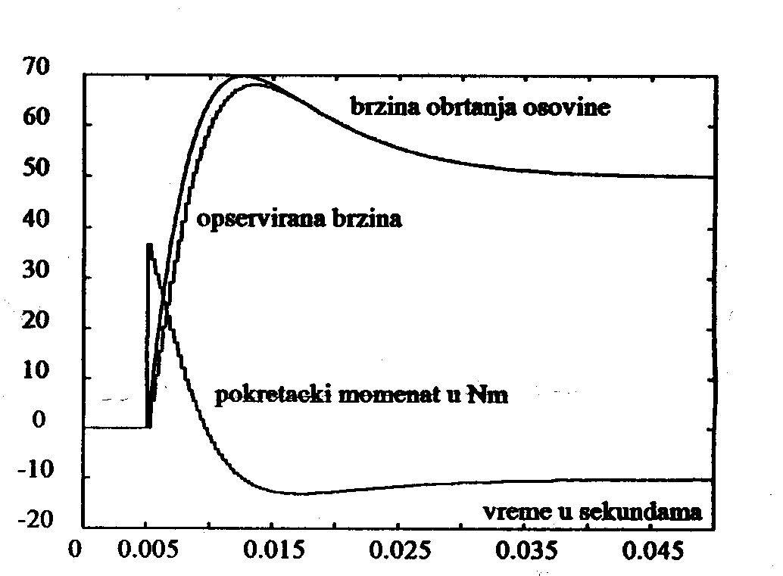

Figure 1: Simulation results

Table 1: Parameters and speed
 | Parameter 1 | Parameter 2 | Parameter 3
Speed 1 | 23 | 75 | 90
Speed 2 | 12 | 55 | 67

Number all your equations, as following (use either the Microsoft Equation Editor: Insert > Objects > Create New > Microsoft Equation > or MathType Equation):

$J\frac{dω\left(t\right)}{dt}+Fω\left(t\right)=T_{e}\left(t\right)−T_{o}\left(t\right)\text{.}$ (1)

Text that should be bulleted, define as following:

- Duis XXXXXXXXXXXXXXXXXXXXXXXXXXXXXXXXXXXXXXXXXXXXXXXXXXXXXXXXXXXXXXXXXXXXXXXXXXXXX

3. SECTION (RESULTS)
Describe the empirical results of research xxxxxxxxxxxxxxxxxx xxxxxxxxxxxxxxxx xxxxxxxxxxxx xxxxxxxxxxxxxx xxxxxxxxxxxxxxxx xxxxxxxx xxxxxxxxxxxxxxxxxxxxx xxxxxxxxxxxxxxxxxxx.
3.1 Subsection
XxxxxxxxxxxxxxxxxxxxxxxxxxxxxxxxxxxxX
4. SECTION (DISCUSSION)
Nam lixxxxxxxxxxxxxxxxxxxxxxxxxxxxxxxxxxxxxxxxxxxxxxxxxxxxxxxxxxx xxxxxxxxxxxxxxxxxxxx xxxxxxxxxxxxxx xxxxxxxxxxxxxxxxxxber.
5. SECTION (CONCLUSIONS)
At xxxxxxxxxxxxxxxxxxx xxxxxxxxxxxxxxxxxxx x.
6. ACKNOWLEDGMENTS
Use the singular heading even if you have many acknowledgments.
7. REFERENCES (Alphabetically ordered, Align Left)*
British Standards Institution. (2003) BS 5950-8:2003. Structural use of steelwork in building: code of practice for fire resistant design. London, British Standards Institution.
Chhibber, P. K. & Majumdar, S. K. (1999) Foreign ownership and profitability: Property rights, control, and the performance of firms in Indian industry. Journal of Law & Economics. 42 (1), 209-238. Available from: doi: 10.1086/467423
European Space Agency. (2015) Rosetta: rendezvous with a comet. Available from: http://envisat.esa.int/ [Accessed 15th june 2015]
Leckenby, R .J. (2005) Dynamic characterisation and fluid flow modelling of fractured reservoirs. PhD thesis. Imperial College London.
Partridge, H. & Hallam, G. (2007) Evidence-based practice and information literacy. In: Lipu, S., Williamson, K. & Lloyd, A. (eds.) Exploring methods in information literacy research. Wagga Wagga, Australia, Centre for Information Studies, pp. 149-170.
Simons, N. E., Menzies, B. & Matthews, M. (2001) A Short Course in Soil and Rock Slope Engineering. London, Thomas Telford Publishing.
Williams, M. (2004) Footwear hanger. UK Intellectual Property Office GB2409807 (Patent).
Wittke, M. (2006) Design, construction, supervision and long-term behaviour of tunnels in swelling rock. In: Van Cotthem, A., Charlier, R., Thimus, J.-F. and Tshibangu, J.-P. (eds.) Proceedings of the International Symposium of the International Society for Rock Mechanics, EUROCK 2006, 9-12 May 2006, Liège, Belgium. London, Taylor & Francis. pp. 211-216.

NOTE: Submit papers on the platform offered on the website http://www.iim.ftn.uns.ac.rs/is23 when registering.

* After each reference example, there is an Endnote carrying information about reference type
Standard
Journal Article (provide doi number if it exists)
Web Page
Thesis
Chapter in Edited Book
Book
Patent
Conference Paper

