Instructions for Authors submitting a paper for TEAM 2018

J. Danyi ª, A. Stoic ^{b}
ª Institution Name, Street and Number, Postal Code City, State, E-mail Address
^{b} Institution Name, Street and Number, Postal Code City, State, E-mail Address

Abstract

In abstract author(s) should give answers for the following question: What is the reason(s) for writing the paper or the aims of the research? Please include the main method(s) used for the research. What is the approach to the topic? What outcomes and implications for practice, applications and consequences are identified? Full text of an abstract should contain no more than 2000 characters (including spaces).

Keywords: Please do provide up to five keywords which corresponds to the section topics of the paper. First keyword must be selected from the chosen set of the section titles.

Introduction
The paper should begin with the introduction in which the literature review of the issues concerning the paper topic will be presented generally and concisely. It is necessary to quote references in accordance with the remarks included in the section “References”.
The official Language for the paper preparation for publishing and for paper presentation is English. Each manuscript must be accompanied by a statement that it has not been submitted for publication elsewhere in English. The Board of TEAM Conference place great emphasis on the quality of the published papers.
Papers will be sent to 2 experts for their peer review. The reviewers’ recommendations determine whether a paper will be accepted/ accepted subject to change/ subject to resubmission with significant changes/ rejected. For papers which require improvements, the same reviewers will be used to ensure that the quality of the revised paper is acceptable.
The Editor-in-Chief reserves the right to refuse any manuscript, whether on invitation or otherwise, and to make suggestions and/or modifications before publication.
Manuscripts which have been accepted become the property of the Publisher [1]. It is a condition of acceptance that copyright shall be transferred to the Publisher.
The Publisher shall not be held responsible for errors which are the result of authors' oversights.

Methods and materials used for research
It is necessary to present in details assumptions of study to such an extent manner that a reader could repeat that work if he/she was going to confirm achieved results. This information should be given in as short as possible version.

2.1. Subtitle
The paper title should precise clearly and in details its subject matter and should have no more than 10 words.

2.2. Formatting of Text
The paper should be prepared according to the requirements provided in Table 1. Please pay attention to the fact that the subsection should be not shorter than a half of the column.

2.3. Formatting of Tables
Tables should be formatted like the form shown in Table 1. They should be arranged over the text but do not put the table at the first page, preferably being included on the same page as they are first discussed. They should have a self- contained caption and be positioned in flush-left alignment with the text margin within the column. If they do not fit into one column they may be placed across both columns.

Table 1. Instructions for Authors.
No | Item | Description
1. | Paper size | Please use standard A4 format (210 x 297) without page numbering. Only this paper size will be accepted by the Editor-in-Chief.
2. | Margins /Columns | All margins: 2.5 cm; Columns: each column 7.6 cm wide with 0.8 cm middle margin do not begin a new section directly at the bottom of a page, but transfer the heading to the top of the next column; you may exceed the length of the text area by one line only in order to complete a section of text or paragraph.
3. | Page layout | The main body of the text should be left and right justified. Do not end the page with a heading; do not start a page with an incomplete line; do not underline any part of the text.
4. | Fonts and line spacing | The 11 pt Times New Roman font in 1.0 line spacing is required.
5. | Title | The title should have no more than 10 words (articles are not counted) and situated in two lines and centre-justified Title of the paper (20 points, bold, Verdana), Authors’ initial and surnameª (11 points, bold, Verdana) and the name of ªDepartment, University, Address, City, Country, (each 10 points, Verdana).
6. | Abstract | Please provide a structured abstract (10 points, Verdana). The words purpose, design and next sub-headings should be written in a bold style (9 points, please do not cancel them), and the abstract itself should contain no more than 2000 characters (including spaces). Please write concisely and clearly. The abstract should reflect only what appears in the original paper. The word Abstract should be written in the bold style (12 points, Verdana).
7. | Keywords | The words Keywords (9 points, Verdana, each beginning with a big letter and separated by semicolon).
8. | Style | Section headings (12 points, bold, Verdana), subsection headings  (10 points, bold, Verdana) should be left justified. Before section headings use two blank spaces and before subsection headings use two blank spaces. The creation of sub-subsections is not foreseen. Table and figure headings (10 points, italic) should be numbered consecutively and centre-justified.
9. | Colour | Papers will be printed as black and white.

2.4. Formatting of Figures
Figures should be formatted as shown in Figure 1. They should be clearly displayed by leaving at least single line of spacing above and below them.
When placing a figure at the top of the page, the top of figure should be at the same level as the bottom of the first text line. All notations and lettering should be no less than 2.5 mm high.
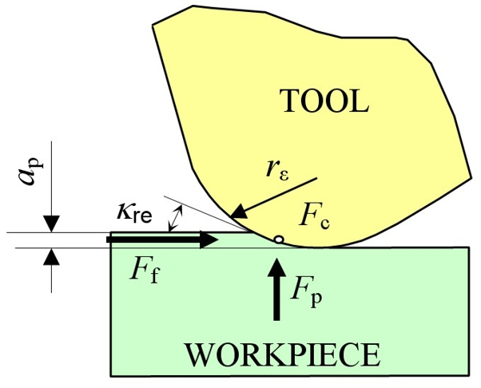
Fig. 1. Good quality figure with clear lettering

The use of heavy black and/or colour bold lettering should be avoided as they will look unpleasantly dark when printed. They also must be located close to the first reference to them in the text and numbered consecutively. A figure caption should be placed immediately below the figures. Photographs and figures should be prepared in colour at min. 300 dpi resolution. Please do not use patterns in vector graphics. It is required to prepare them in TIFF or JPEG format (prepared in MS Word are not accepted). Please remember that they cannot be reduced or enlarged after placement in MS Word application, because they lose the image quality.
Tables and figures placed across both columns should not begin at the end of the page (it shall not be divided, if you cannot avoid it, use the same header of the table also to the start of the next page without labelling the table on next page).

2.5. Equations
Equations should be placed flush-left with the text margin of the column and should be preceded and followed by one blank line.
$S_{\text{ktz}}(t)=d^{3}−d_{i}\sum_{i=1}^{f}{s_{i}}$ (1)
If they are numbered make sure that they are numbered consequently starts from 1 upwards. Put the numbers in parentheses flush with the right- hand margin level with the last line of the equation.

Results and achievements

Try to avoid the free space without text between the headings.

3.1. List of results
In this section it is necessary to present achieved results of own researches in details e.g. researches or calculations, illustrating them in details and legibly by pictures, diagrams, photos e.g. metallographic ones, results, calculations, tables etc. and giving in details casual and result relations between stated facts confirming or excluding data known from the literature. This section should have a character of a scientific discussion, although in order to do that the separate section can be created and in the given one only the information about achieved results of researches can be included.

3.2. Sections and topics
Thematic sections and topics of papers are listed below:
PRODUCTION ENGINEERING
Advanced Manufacturing Technologies, Industrial Logistics, Product Design, Product Development
KNOWLEDGE TRANSFER
Computer Technologies and Applications, Education, Engineering, Pedagogy and Didactics, Kinesiologic Education in the Function of Health Prevention, Mobility in Education
BIOTECHNOLOGY IN AGRICULTURAL ENVIRONMENT
Advanced Technology and Technics in Agriculture, Agroecology and Organic Farming, Landscape Architecture and Decoration, Plant Protection, Wine and Fruit Production
MARKET-ORIENTED MANAGEMENT
Cost Management, EU Funding, New Opportunities in Financial Entrepreneurship

Conclusions
It is necessary to present the main conclusions and achievements from the study. The author’s achievements and originality of research and the authors’ input in the undertaken subject matter and value of study should be emphasised. Practical application and possible outcomes as well as directions of further works can be pointed out. Conclusions should also summarise gained results in relation to defined aims.

Acknowledgements
In this part author can thank to people and institutions co-operating in the research or mention the name of the grant or project name and the name of the funding agency.

References
- W.M. Smith, Surface Materials Processing. Second Edition, Backmann Verlag, Berlin–London–Paris–Warsaw, (2006).
- J. Kopač; S. Šali, Tool wear monitoring during the turning process. Journal of Materials Processing Technology 113 (2001), pp.312-316
- Roller Burnishing Technology, Yamasa, http://www.yamasa.com.tr, last access dd/mm/yyyy

References should be collected and listed at the end of your paper. Please do not begin the list on a new page unless this is absolutely necessary. They should be listed in the order in which they are cited in the text. Citation of reference should be made within square brackets at the end of the certain cited section. Please write full titles of Journals and papers.
The list of references should include at least 5 items. If references are not written in English their titles should be written in English transliteration, and in the bracket it is necessary to give a language of the original (e.g. in Hungarian). One should not referee more than 25% of papers of his/her own authorship or co-authorship.
Please use the whole space. The paper should finish sharp at the end of second column of the page.

Do not leave the free space
if possible. Use whole space to explain your experimental and subsequent research activities.

